WEBSITE URL ADDRESS: _________________________________________________

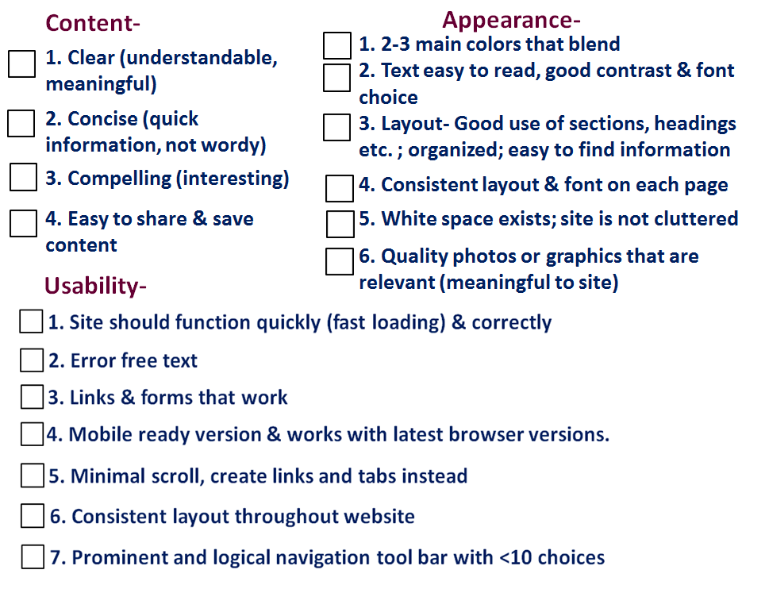

FEEDBACK (Suggestions for improvements):

