Tree Identification Key
Directions:
Always start at top for each new specimen and choose between 1A or 1B. Then keep following the directions for which number to go to next. (You will not necessarily go to all of the numbers.) Keep making choices between A or B until you end with the name of the tree.

Do you have…

1A: Broadleaf (tree with leaves that are thin, flat, & usually fall off each year) If so, Go to #2
or
1B: Conifer (tree that bears cones & needles for leaves or scale-like leaves) If so, Go to #3

2A: Leaves are SIMPLE (one blade attached to the leaf stalk or petiole) If so, Go to #20
or
2B: Leaves are COMPOUND (more than 1 blade attached to the leaf stalk or petiole. If so, Go to #21

3A: Does the conifer have NEEDLE-LIKE leaves? If so, Go to #4
or
3B: Does the conifer have SCALE-LIKE leaves? If so, Go to #5

4A: Are the needles attached SINGLY, each needle attached directly to the twig? If so, Go to #8
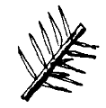

Or

4B: Are the needles attached in BUNDLES or CLUSTERS of needles? If so, Go to #9
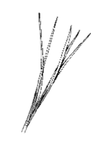

5A: Have blue, berry-like cones with both scale & awl shaped leaves? If so, Go to #6
Or
5B: have scale like leaves in a flattened fern-like shape? If so, Go to #7

6: You have discovered a JUNIPER! (or Eastern Redcedar) The wood of this tree is able to resist the effects of moisture and is very fragrant. The berries are often eaten by many kinds of birds.

7: You have discovered an EASTERN ARBORVITAE! (or Northern Whitecedar)

8A: Are the needles flat? If so, Go to #10
Or
8B Are the needles square (4-sided)? If so, Go to #11

9A: Does your tree have soft, DECIDUOUS (shed in fall) needles growing in clusters? If so, Go to #16
Or
9B: Does your tree have EVERGREEN needles growing in bundles of 2-5 & do not shed in the winter?
If so, Go to #17

10A: Does your tree have short needles, less than 1” long, and a small cone that hangs down?
If so, Go to #12
Or
10B: Does your tree have needles over 1” long with cones that grow upward? If so, Go to #13

11A: Does your spruce tree have blue-green or silvery blue needles with a cone that is 2-4” long?
If so, Go to #14
Or
11B: Does your spruce tree have dark green needles and a cone 4-8” long? If so, Go to #15

12: You have discovered a HEMLOCK! Native Americans and early settlers valued the hemlock for the tannin in its bark which was used to prepare hides to make leather.

13: You have discovered a FIR (White Fir)! White firs do not begin producing cones or seeds until the tree is about 40 years old! Firs are often used as Christmas trees.

14: You have discovered a COLORADO BLUE SPRUCE! This tree is popular for decorative landscaping because of its unusual color.

15: You have discovered a NORWAY SPRUCE! These trees are recognized by their drooping branches.

16: You have discovered a LARCH! Species include the Tamarack or Eastern larch, western larch, European larch, and subalpine larch.

17A: Does your pine tree have needles held in BUNDLES of 5? If so, Go to #18
Or
17B: Does your pine tree have needles held in BUNDLES of 2? If so, Go to #19

18: You have discovered an EASTERN WHITE PINE! Towering white pines have been used as masts for ships in Colonial America.

19: You have discovered a SCOTCH PINE! While it is an adaptable tree, it is vulnerable to disease.

20A: Do the SIMPLE leaves have an OPPOSITE arrangement? (Leaves located directly across from each other on the same twig.) If so, Go to #22
Or
20B: Do the SIMPLE leaves have an ALTERNATE arrangement? (Leaves staggered, not directly across from each other on the same twig.) If so, Go to #23

21A: Do the COMPOUND leaves have an OPPOSITE arrangement? (Leaves located directly across from each other on the same twig.) If so, Go to #24
Or
21B: Do the COMPOUND leaves have an ALTERNATE arrangement? (Leaves staggered, not directly across from each other on the same twig.) * Remember to look at leaves on the leaf stalk, not leaflets.) If so, Go to #25

22A: Are the simple, opposite leaves LOBED? If so, Go to #30
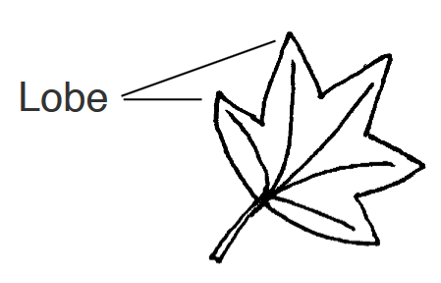
Or
22B: Are the simple, opposite leaves NOT LOBED? If so, Go to #31

23A: Are the simple, alternate leaves LOBED? If so, Go to #34
Or
23B: Are the simple, alternate leaved NOT LOBED? If so, Go to #35

24A: Are the leaves PINNATE and COMPOUND (with blades or leaflets arranged like a feather)?
If so, Go to #26
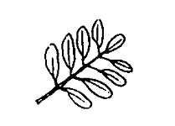
Or
24B: Are the leaves PALMATE and COMPOUND (with blades or leaflets arranged like fingers on the palm of a hand)? If so, Go to #27
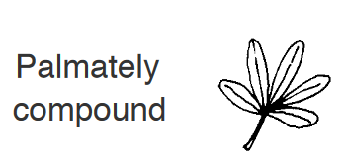

25A: Are the leaves only ONCE PINNATE & COMPOUND? If so, Go to #44
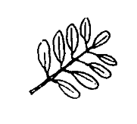
Or
25B: Are the leaves TWO OR THREE TIMES PINNATE & COMPOUND? If so, Go to #45
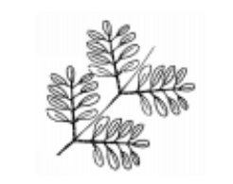

26A: Are there generally 3-5 BLADES that are LOBED or very coarsely toothed, and is the fruit a double SAMARA (winged seed)? If so, Go to #29
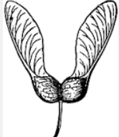
Or
26B: Are there generally 5-13 BLADES that are NOT LOBED, and is the fruit a single SAMARA? If so, Go to #28
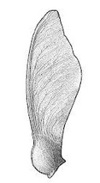

27: You have discovered the OHIO BUCKEYE! These trees have nut-like seeds that are shiny and dark brown with a light-colored spot that gives them the appearance of a deer’s eye. While these seeds are poisonous to eat, they are believed to bring good luck if you carry one in your pocket.

28: You have discovered an ASH! There are a number of species of Ash in the United States including green ash, white ash, and blue ash. Ash wood is hard and durable; it is often used for tool handles and baseball bats.

29: You have discovered the BOXELDER (or Ashleaf Maple)! This tree has weak wood and is not used for lumbar, but its seeds are eaten by a variety of wildlife.

30: You have discovered a MAPLE tree! Maple trees have winged seeds, calls SAMARAS, that flutter to the ground like little helicopters. The wood of the maple is both strong and beautiful.

31A: Does your tree have LARGE, HEART SHAPED LEAVES and a long BEAN-LIKE SEED POD? If so, Go to #32
Or
31B: Does your tree have leaves with veins that follow the leaf edge and a BERRY-LIKE FRUIT? If so, Go to #33

32: You have discovered a CATALPA! It has showy blossoms in the early summer followed by the distinct slender seed pods.

33: You have discovered a DOGWOOD! They are often planted as ornamental trees because of their lovely spring flowers. In the fall berries provide food for birds.

34A: Is the seed or fruit an ACORN in a cap? If so, Go to #42
Or
34B: Is the seed or fruit NOT an ACORN? If so, Go to #43

35A: Are the LEAF MARGINS ENTIRE (SMOOTH EDGED)? If so, Go to #37
Or
35B: Are the LEAF MARGINS TOOTHED (JAGGED EDGED)? If so, Go to #36

36A: Are the LEAVES LONG with sharp TEETH and is the fruit a NUT in a SPINY CAP? If so, Go to #38
Or
36B: Are the LEAVES HEART-SHAPED & is the fruit a few BERRY-LIKE SEEDS attached to a leaf-like bract?
If so, Go to #39

37A: Are the leaves heart shaped, is the fruit a small pod and are the spring blooms purple? If so, Go to #40
Or
37B: Are the leaves oval shaped, are the flowers large and showy, and do the flowers grow at the branch tips?
If so, Go to #41

38. You have discovered a CHESTNUT tree! The American Chestnut was once widely planted, but have been damaged by widespread blight disease.

39: You have discovered a LINDEN or BASSWOOD! Their soft, lightweight wood is often used for carving.

40: You have an EASTERN REDBUD! These trees bloom in early spring with a bright purple color. They grow well in shade.

41: You have discovered a MAGNOLIA!

42: You have discovered an OAK! There are 58 species of oak native to North America. All oaks make acorns. Oak is a strong wood used in building and furniture.

43: You have discovered a TULIP TREE or Tulip Poplar! Not only an important timber tree, the tulip tree is prized for its beautiful, yellow-orange, tulip like blossoms that appear in early summer.

44: You have discovered a BITTERNUT HICKORY! The nut of this tree is so bitter even a half-starved squirrel often passes it up.

45: You have discovered a HONEYLOCUST! These trees have a long, brown, leathery pod with seeds. In the wild these trees have sharp thorns, but they are available without thorns and made a hardy, city tree.

