Certificate Of Completion
This certifies that

_____________________________________________
has successfully completed the requirements to earn the scouting badge for
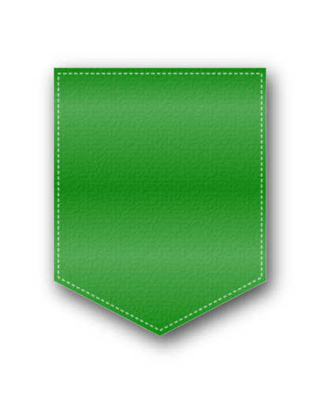
AMAZING TREES /
TREES CADETTE BADGE

Given this ___ day of __________, 20__
Virtually Badges Online Workshop
VirtuallyBadges.weebly.com

